Project Design Phase
Solution Architecture
Date | 22-09-2026
Team ID | SWTID-2026-1780
Project Name | AI FAQ Assistant
Maximum Marks | 4 Marks

Solution Architecture:
The AI FAQ Assistant is designed to connect users with reliable answers through a simple conversational system. It receives a question, processes the user's intent, searches a verified FAQ or knowledge base, and generates a relevant response. If the system cannot find a suitable answer, the query can be transferred to human support.
• Provide an easy interface for users to ask questions in natural language.
• Identify the user's intent and match the question with information stored in the FAQ knowledge base.
• Generate concise and understandable answers using the retrieved information.
• Maintain a clear fallback path to human support for questions outside the assistant's knowledge.

AI FAQ Assistant – Solution Architecture Diagram:
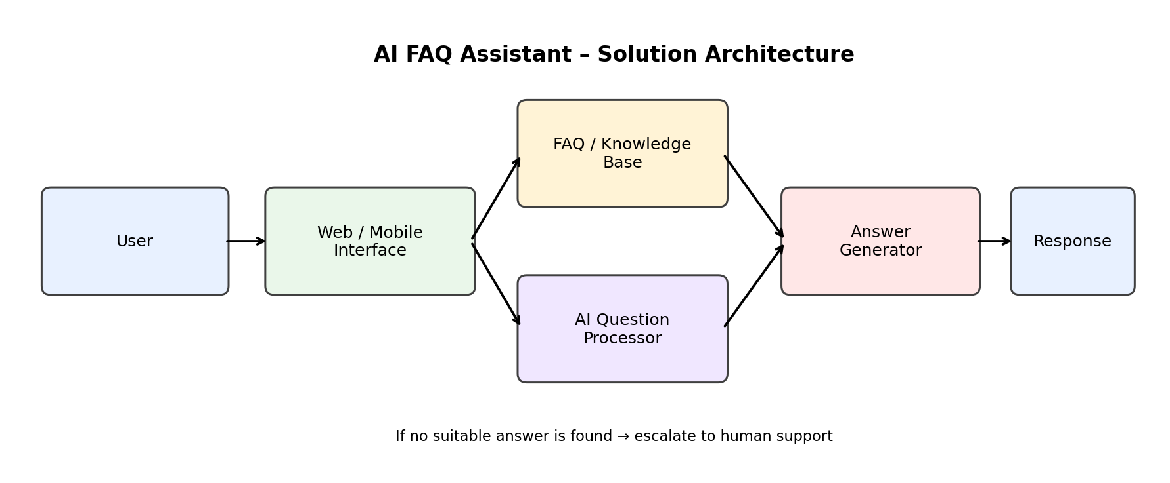
Figure 1: Data flow and components of the AI FAQ Assistant
Reference: AI FAQ Assistant – conceptual solution architecture prepared for the project.

